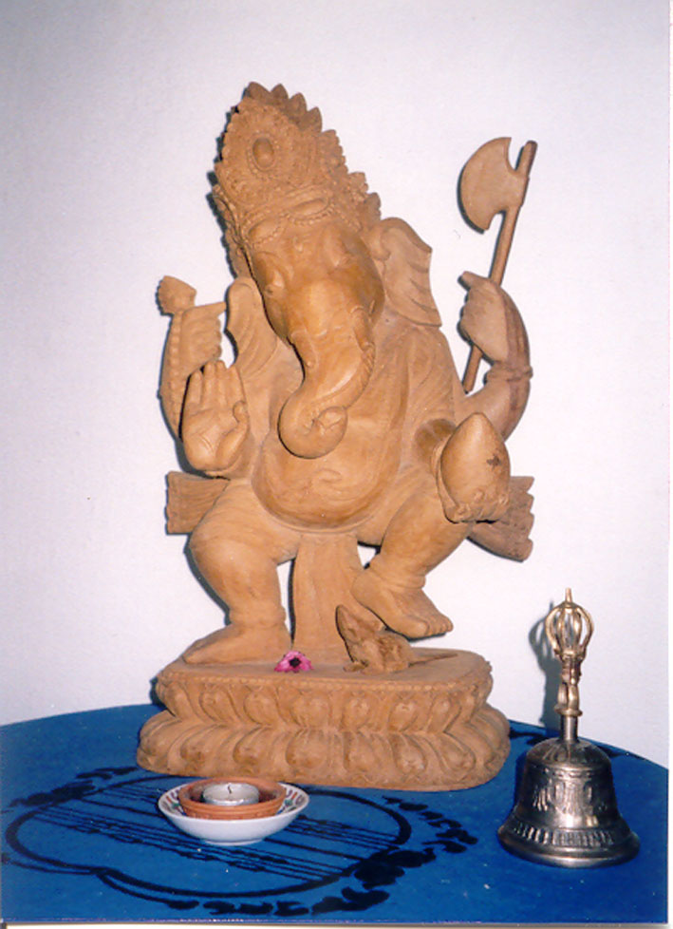
Association Ganesha
p.a. Josiane Perrier Cathomen
Av. d’Echallens 4a)
1004 Lausanne
Tel. : 021 / 625’16’53 Lausanne, 30 July 2026
Mobile : 078 / 666’77’93

MEMBERSHIP APPLICATION FORM

I, the undersigned, wish to apply for membership of the Association Ganesha.
I agree to be bound by the rules and regulations of the association and commit myself to support its work to the best of my ability. I confirm I will pay the one-time joining fee, as well as the annual membership fee, in time.

Last Name / First Name : _________________________________________________________

Address : _____________________________________________________________________

Postal Code : _______________ City : _______________________________________________

Home Telephone : ___________________________ Mobile : _____________________________

Email : _______________________________________________________________________

Profession / Current Occupation : _______________________ Company : ____________________

Business Address : ______________________________________________________________

Postal Code : ________________ City : ______________________________________________

Email : _______________________________________________________________________

I would like to help the association as a member of the committee : YES □ NO □ *
I am interested in undertaking the post of : ________________________________________

I would like to become a member and pay Fr. 50.- □ *
- the copper joining fee of Fr. 100.- □
- the silver joining fee of Fr. 250.- □
- the gold joining fee of Fr. 500.- □
- the diamond joining fee of Fr. 1'000.- □

* Please put a cross in the box for the category of your choice.

- 2 -

Additional information

1. I am interested in participate to a trip to Nepal YES □ NO □ *
(Please send me additional information)

2. I want to share with you the following additional information :

__________________________________________________________________________________________________________________________________________________________________________________________________________________________________________________________________________________________________________________________________________________________________________________________________________________________________________________________________________________________________________________________________________________________________________________________________________________________________________________________________________________________________________________

* Please put a cross in the box for the category of your choice.

Date : _________________ Signature : ______________________________________

